**DEFECT 1.**

Module : “DELETE HOTEL” uses hotel id to fire query. This is a loophole as Admin doesn’t know the hotel name to delete just by looking at the hotel id.

**ScreenShot 1 for defect1:**

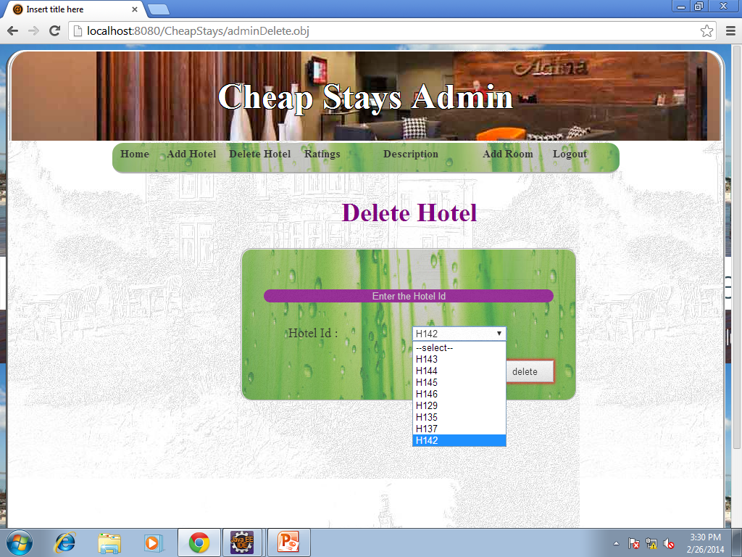

**Solution :**

Use hotel name in the dropdown list instead of hotel id.

**Defect 2.**

Resolution Problem:

Pages giving unnecessary horizontal scrolls due to unsupportive resolution.

**Screenshot 1 of defect2 :**

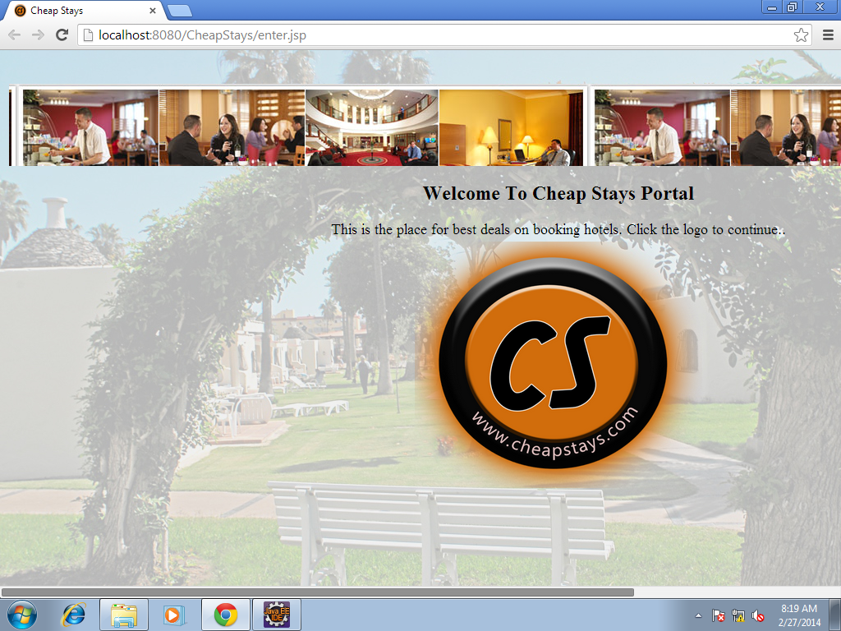

**Screenshot 2 of defect2 :**

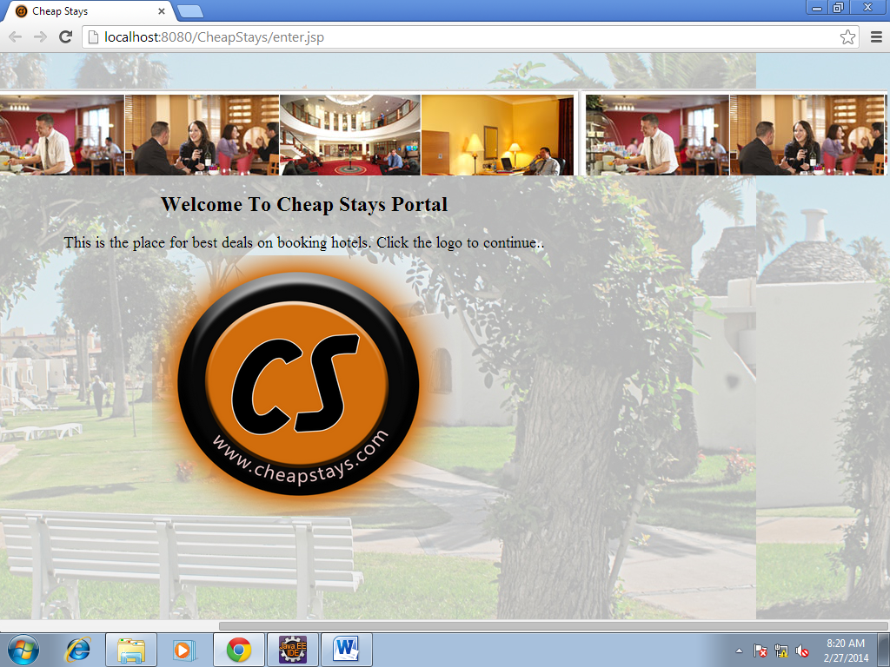

**Screenshot 3 of defect2 :**

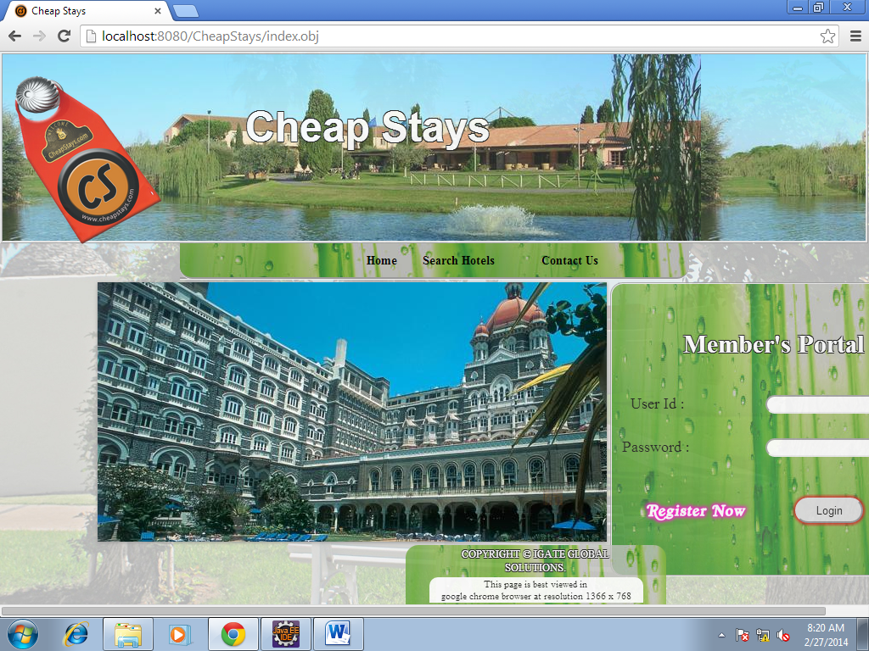

**Solution:**

Need to adjust pagesize according to resolution.

**Defect 3.**

List of hotels- long listing used

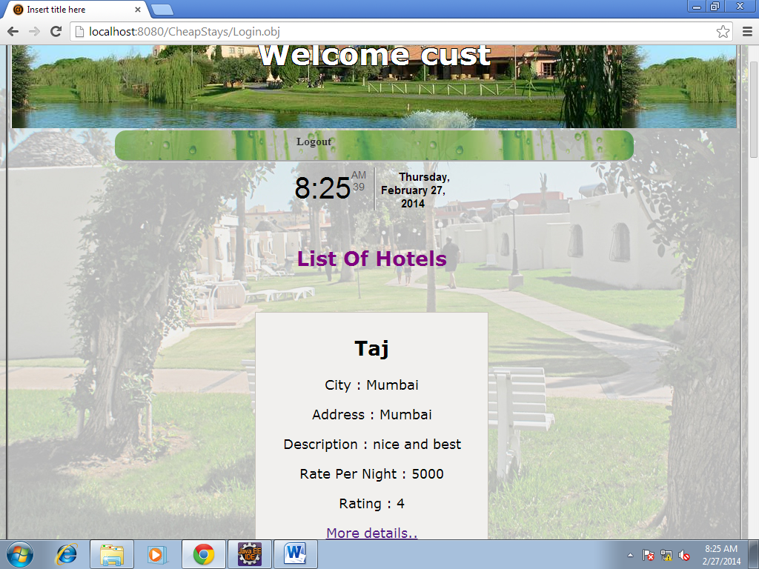

**Solution:**

Paging method should be introduced.

**Defect 4.**

Change password is not provided.

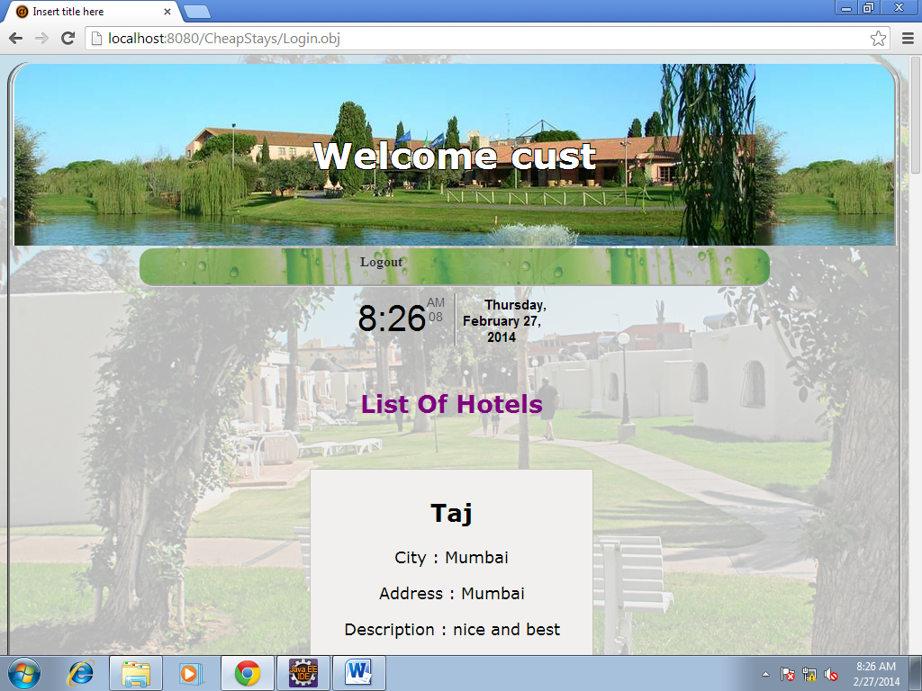

**Solution:**

Include change password option.

**Defect 5.**

ADD ROOM redirects to 404 error.

**Screenshot 1 of defect 5 :**

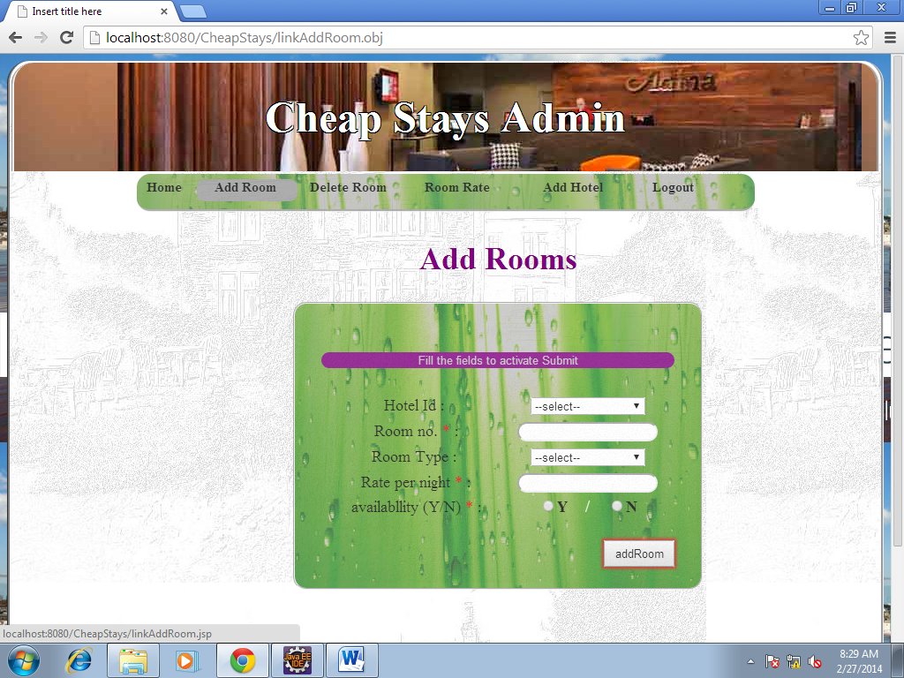

**Screenshot 2 of defect 5 :**

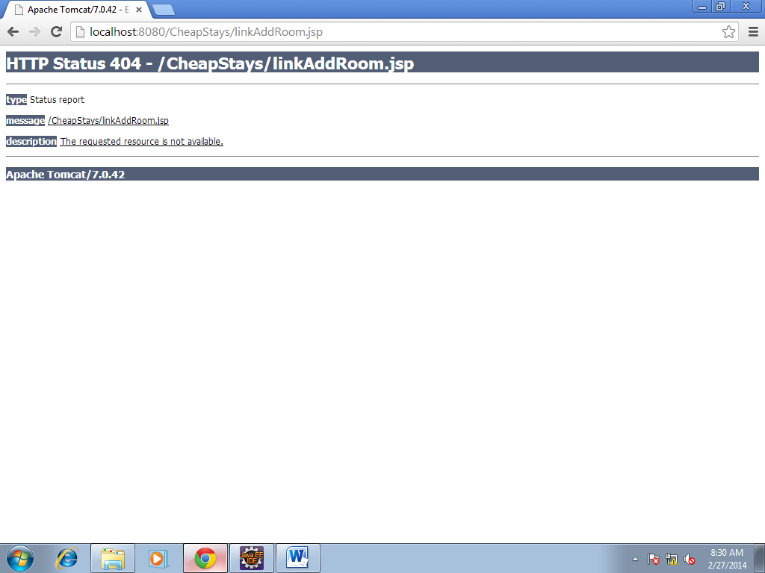

**Solution:**

Redirect to the same page.

**Defect 6.**

Minimun 1 adult required to book a room.

Same day checkin checkout gives bill amount 0.

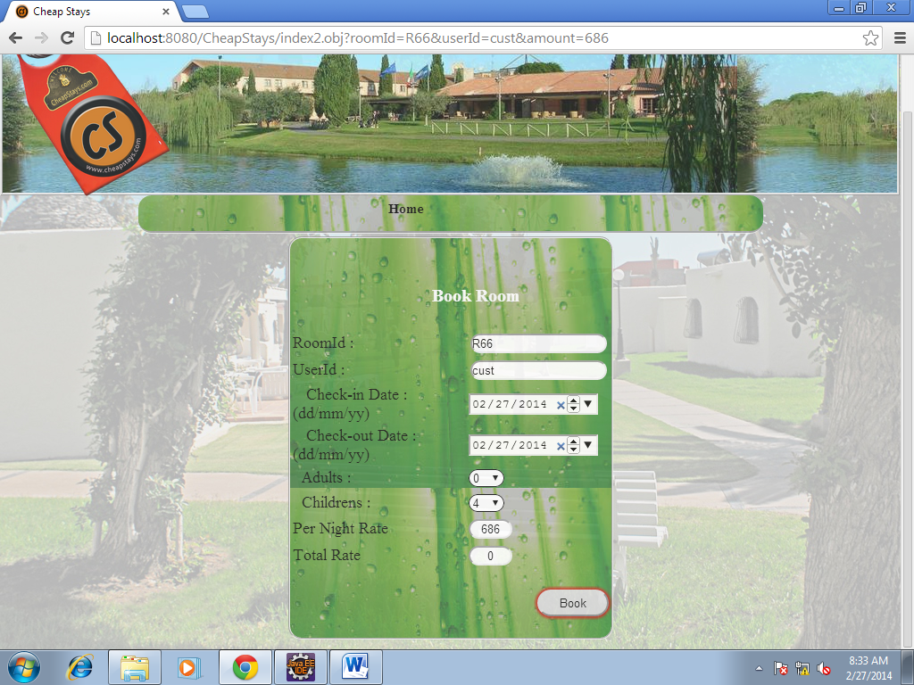

**Solution:**

Improve the validation.

**Defect 7.**

Admin -> Reports ->

Gives a list of hotels registered.

All hotels list may be too long.

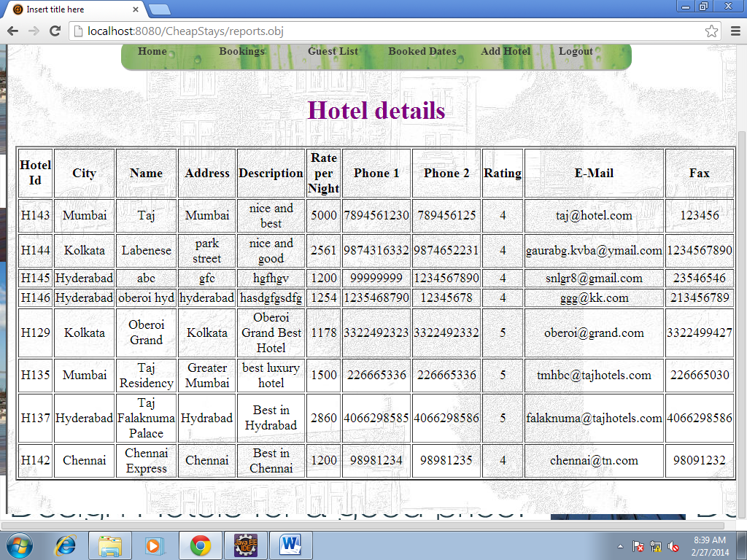

**Solution:**

Paging method should be used.

**Defect 8.**

Admin -> Guest List

Text box given for hotel name.

**Screenshot 1 of defect 8 :**

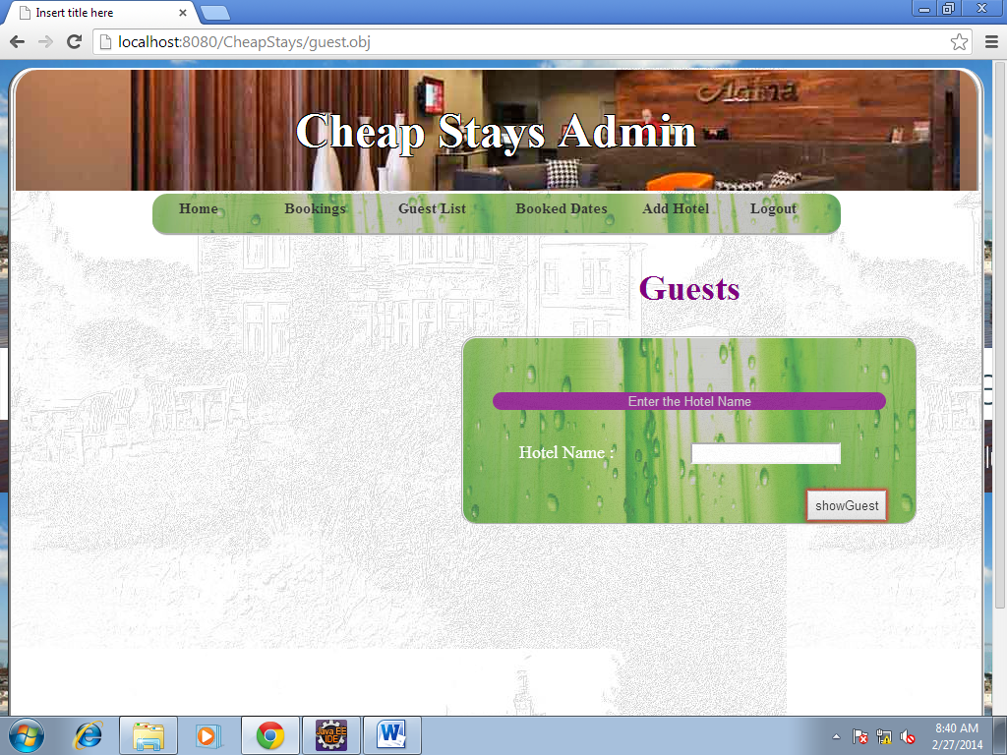

Admin -> Bookings

Text box given for hotel name.

**Screenshot 2 of defect 8:**

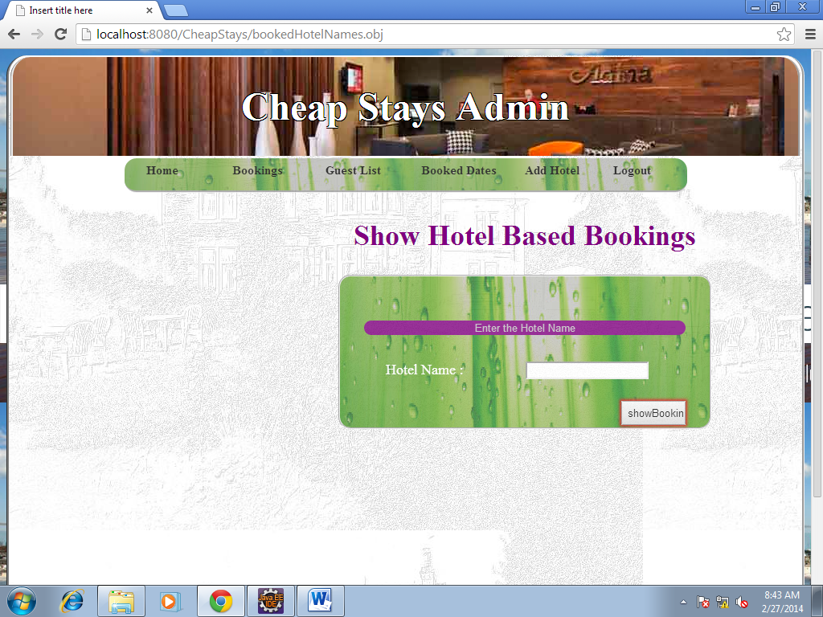

**Solution:**

Dynamic drop down will be better option.

**Defect 9.**

IF no hotel name entered,

Redirected to error page with no further redirection.

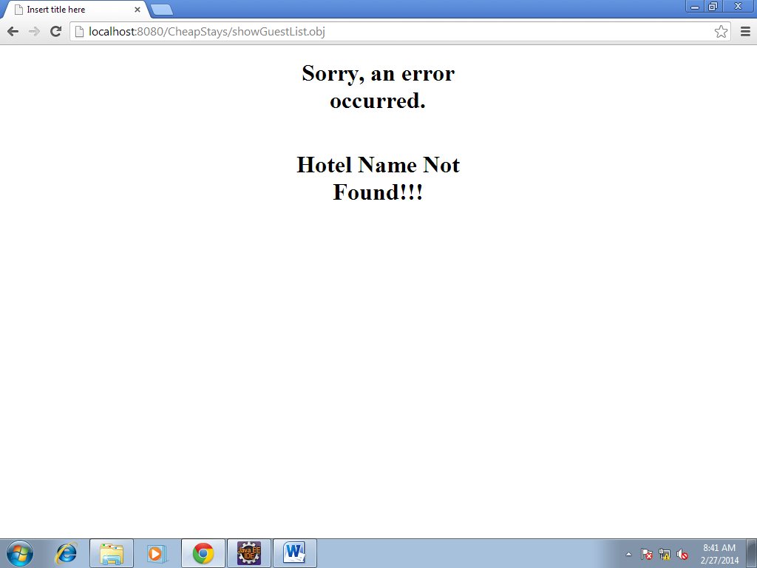

**Solution:**

Insert a link for navigation.

**Defect 10.**

Admin -> Ratings

Hotel id used instead of hotel name.

Admin cannot remember all id’s.

>>>> **Ratingss : spelling mistake.**

**Screenshot 1 of defect 10 :**

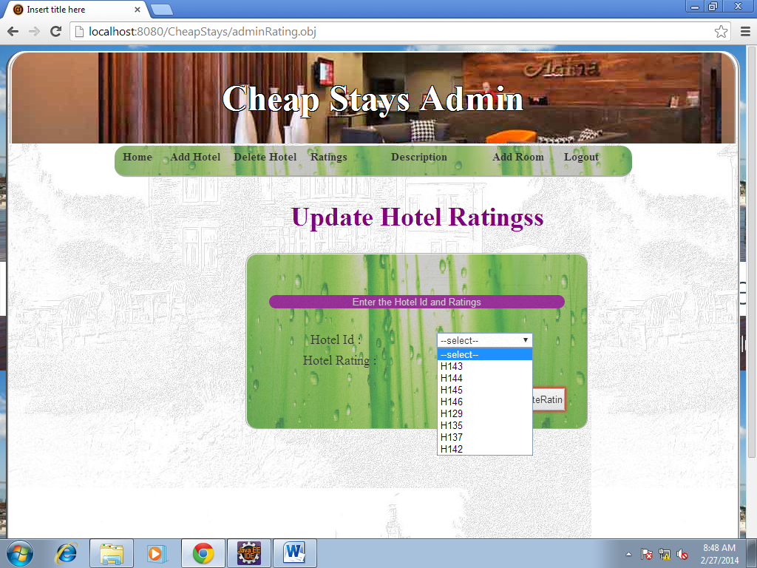

Admin -> Description

Hotel id used instead of hotel name.

Admin cannot remember all id’s.

**Screenshot 2 of defect 10:**

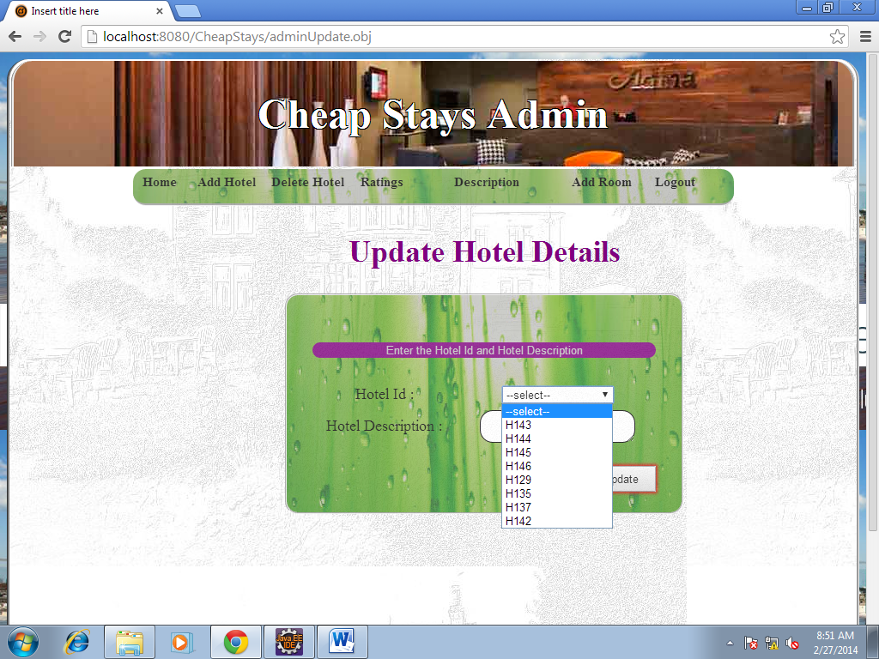

**Solution:**

Display hotel names instead of displaying the hotel id’s. Correct the spelling mistake in the UI.

**Defect 11.**

IF no rooms are available, no message is displayed.

**Screenshot 1 of defect 11 :**

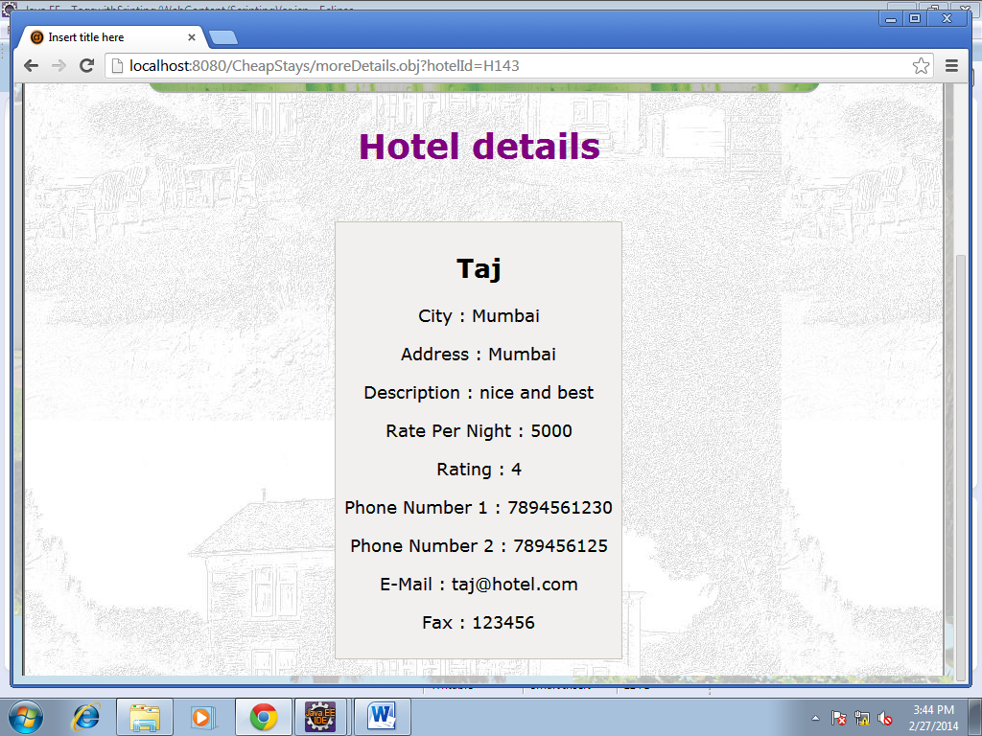

**Screenshot 2 of defect 11 :**

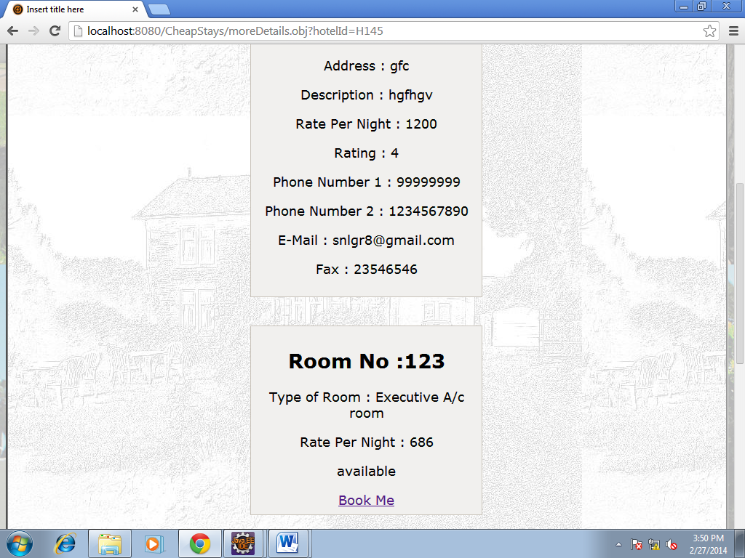

**Solution:**

Display appropriate message.